FG Knot:
Step 1
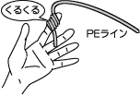
In 1st joint of left hand index finger PE line 10? 12 times it can be coiled round

Step 2
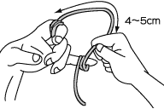
The main lane of PE it can be coiled round to the little finger the branch line from the わ, (6? 7 times) Note: With the index finger, you adjust the size of the loop at the frequency which winds around the direction little finger which is not reel side

Step 3-1
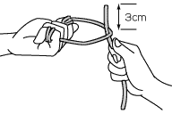
In the right hand it knits PE in the leader with the leader line, with the ヒラ side of the left hand as on, is packed

Step 3-2
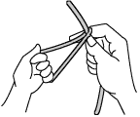
It has the place where PE and the leader hit with the right hand securely

Step 3-3
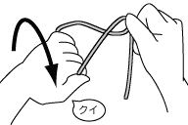
The 180° it turns the left hand foreward

Step 3-4
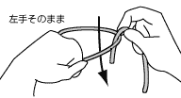
In the wheel of PE the leader line under the ぐ and others is done difficult from above

Step 3-5
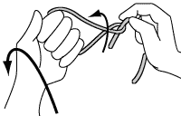
The left hand is reset to foam/home position

Step 4
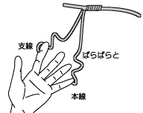
The main lane and the branch line which wind description above in 7 action fingers are removed

Step 5
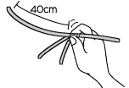
About 40cm it makes the dense winding part move to in and this time grasps the dense winding part, try not to deteriorate

Step 6
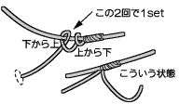
It has the PE main lane and the leader branch line together not to become loose, 1set applies half hitching with the PE branch line
Step 7-1
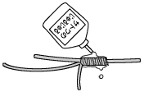
It screws. Questions the "じ ゅ る じ ゅ る" and the lubricating liquid of TAKUMI atelier "sukebe juice" and so on is applied around the dense volume section

Step 7-2
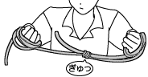
You question "setting the む to the both hands cruelly"! ! The right hand and the PE main lane left hand, with the leader main lane and the PE gaze, it screws lightly with the feeling, "ギュッ". (It makes PE the leader eat and does not move.)

Step 7-3
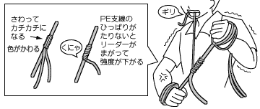
Until in the mouth the PE branch line, the PE main lane, the color of PE of the dense winding section changes to the left hand in the right hand with the leader main lane, the じ it screws extremely! !

Step 8
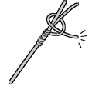
The PE branch line, also the main lane, attaches the じ ゅ る じゅ る. The PE branch line, the right hand, with the む screws to heart cruelly in every half hitching 1 time. Because of this the PE main line and the leader branch line where strength rises steadily the left hand, holding down the leader main lane with the right foot, you apply power on the straight line. The PE main lane which is held down with the left hand and when the leader branch line is collected half hitching 20 times is applied with the PE branch line

Step 9
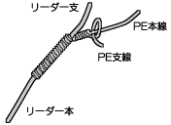
Half hitching 6 times is applied in only the PE main lane. In order to prevent スレ to the PE main lane by the section of the leader

Step 10
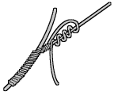
You stop the branch line with 4 time winding

Step 11
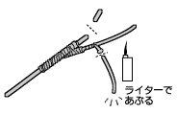
3mm leaving PE and the leader branch line, it cuts, roasts with the lighter/writer. Putting with the nail, in order for heat not to go to knot, you pay attention. When it burns too much to with special care being possible it is not large is here

